Tasks:

1. Inner Join: Write a query to retrieve the details of all orders along with the customer

names and product names. The output should include order_id, customer_name, product_name, order_date, quantity, and total_price.

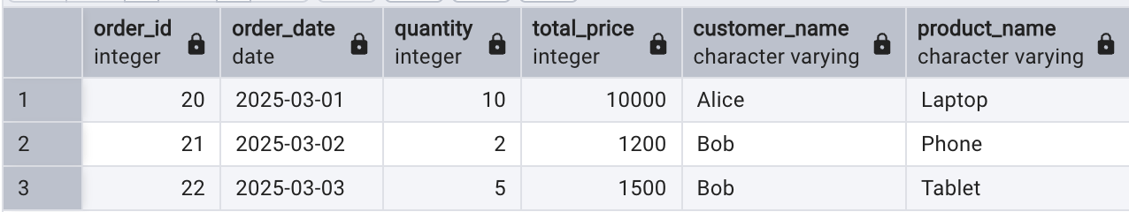

1. Left Join: Write a query to find all customers who have not placed any orders. The output should include customer_id, customer_name, and email.

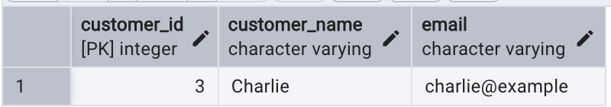

1. Full Outer Join: Write a query to retrieve all customers and all orders, including those customers who have not placed any orders and those orders that do not have a corresponding customer. The output should include customer_id, customer_name, order_id, and order_date.

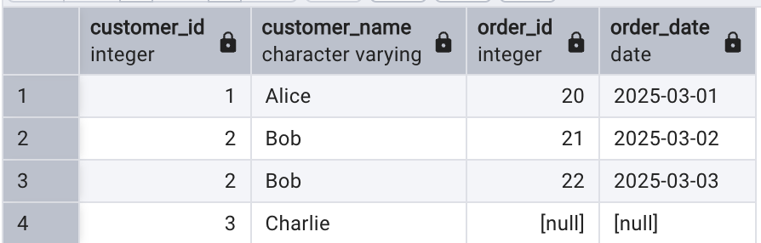

1. Cross Join: Write a query to generate a report that shows all possible combinations of customers and products. The output should include customer_name and product_name.

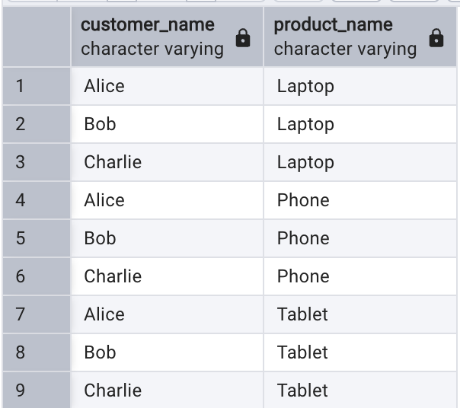

Tasks:

1. Anti-Join: Write a query to find all employees who have not been assigned to any project. The output should include employee_id, employee_name, and department_id.

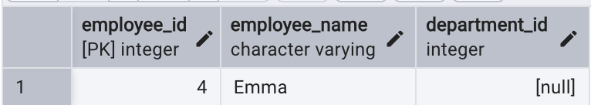

1. Semi-Join: Write a query to retrieve the details of all employees who have been assigned to at least one project. The output should include employee_id, employee_name, and department_id.

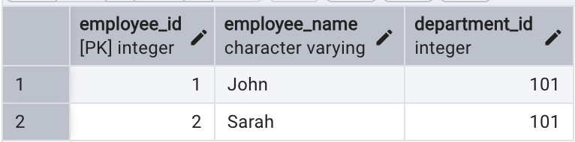

1. Self-Join: Write a query to find pairs of employees who work in the same department. The output should include employee1_name, employee2_name, and department_id.

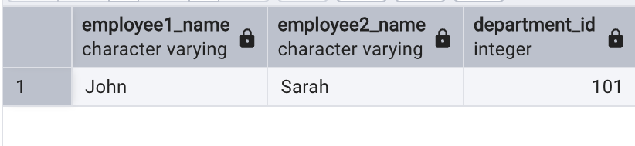

1. Natural Join: Write a query to retrieve the details of all projects along with the employee names using a natural join. The output should include project_id, project_name, employee_name, start_date, and end_date.

